WEB TECHNOLOGY LAB
EXPERIMENT:6

AIM:
To demonstrate session tracking using HttpSession in a Servlet-based web application by implementing an Online Help Desk Support System.

ALGORITHM:
1. Input: The user (customer) enters username and password through a login form. After login, they can submit support tickets. The admin can view and respond to tickets.
2. Steps:
- Create an HTML login form with username and password fields.
- Create a LoginServlet to validate credentials and create a session.
- Retrieve user inputs using request.getParameter().
- Validate credentials (hardcoded for demo).
- If valid:
  - Create a session using HttpSession.
  - Store username and role using session.setAttribute().
- Redirect customer to Ticket Submission Page, admin to Admin Dashboard.
- If invalid: Show error message.
- Create TicketServlet to handle ticket submission and store in session.
- Create AdminServlet to display all submitted tickets.
- Implement logout using session.invalidate().
- Handle session expiration for inactive users.

PROGRAM:
1. HTML Login Page (login.html)
html
<!DOCTYPE html>
<html>
<head>
<title>Help Desk Login</title>
</head>
<body>
<h2>Online Help Desk - Login</h2>
<form action="LoginServlet" method="post">
Username: <input type="text" name="username"><br><br>
Password: <input type="password" name="password"><br><br>
<input type="submit" value="Login">
</form>
</body>
</html>

2. Login Servlet (LoginServlet.java)
java
import java.io.*;
import javax.servlet.*;
import javax.servlet.annotation.WebServlet;
import javax.servlet.http.*;

@WebServlet("/LoginServlet")
public class LoginServlet extends HttpServlet {
protected void doPost(HttpServletRequest request, HttpServletResponse response)
throws ServletException, IOException {
response.setContentType("text/html");
PrintWriter out = response.getWriter();

String username = request.getParameter("username");
String password = request.getParameter("password");

if (username.equals("admin") && password.equals("admin123")) {
HttpSession session = request.getSession();
session.setAttribute("username", username);
session.setAttribute("role", "admin");
session.setMaxInactiveInterval(300);
response.sendRedirect("AdminServlet");

} else if (username.equals("user") && password.equals("user123")) {
HttpSession session = request.getSession();
session.setAttribute("username", username);
session.setAttribute("role", "customer");
session.setMaxInactiveInterval(300);
response.sendRedirect("ticket.html");

} else {
out.println("<h3>Invalid Username or Password. <a href='login.html'>Try Again</a></h3>");
}
}
}

3. HTML Ticket Submission Page (ticket.html)
html
<!DOCTYPE html>
<html>
<head>
<title>Submit Support Ticket</title>
</head>
<body>
<h2>Submit a Support Ticket</h2>
<form action="TicketServlet" method="post">
Issue Category:
<select name="category">
<option>Technical</option>
<option>Billing</option>
<option>General</option>
</select><br><br>
Description: <br>
<textarea name="description" rows="5" cols="40"></textarea><br><br>
<input type="submit" value="Submit Ticket">
</form>
</body>
</html>

4. Ticket Servlet (TicketServlet.java)
java
import java.io.*;
import java.util.*;
import javax.servlet.*;
import javax.servlet.annotation.WebServlet;
import javax.servlet.http.*;

@WebServlet("/TicketServlet")
public class TicketServlet extends HttpServlet {
protected void doPost(HttpServletRequest request, HttpServletResponse response)
throws ServletException, IOException {
response.setContentType("text/html");
PrintWriter out = response.getWriter();

HttpSession session = request.getSession(false);
if (session == null || session.getAttribute("username") == null) {
response.sendRedirect("login.html");
return;
}

String username = (String) session.getAttribute("username");
String category = request.getParameter("category");
String description = request.getParameter("description");

// Store tickets in application scope (ServletContext)
ServletContext context = getServletContext();
List<String> tickets = (List<String>) context.getAttribute("tickets");
if (tickets == null) {
tickets = new ArrayList<>();
}
tickets.add("User: " + username + " | Category: " + category + " | Issue: " + description);
context.setAttribute("tickets", tickets);

out.println("<h3>Ticket submitted successfully, " + username + "!</h3>");
out.println("<a href='ticket.html'>Submit Another</a> | ");
out.println("<a href='LogoutServlet'>Logout</a>");
}
}

5. Admin Servlet (AdminServlet.java)
java
import java.io.*;
import java.util.*;
import javax.servlet.*;
import javax.servlet.annotation.WebServlet;
import javax.servlet.http.*;

@WebServlet("/AdminServlet")
public class AdminServlet extends HttpServlet {
protected void doGet(HttpServletRequest request, HttpServletResponse response)
throws ServletException, IOException {
response.setContentType("text/html");
PrintWriter out = response.getWriter();

HttpSession session = request.getSession(false);
if (session == null || !"admin".equals(session.getAttribute("role"))) {
response.sendRedirect("login.html");
return;
}

out.println("<h2>Admin Dashboard - Help Desk Tickets</h2>");

ServletContext context = getServletContext();
List<String> tickets = (List<String>) context.getAttribute("tickets");

if (tickets == null || tickets.isEmpty()) {
out.println("<p>No tickets submitted yet.</p>");
} else {
out.println("<table border='1'><tr><th>#</th><th>Ticket Details</th></tr>");
int i = 1;
for (String ticket : tickets) {
out.println("<tr><td>" + i++ + "</td><td>" + ticket + "</td></tr>");
}
out.println("</table>");
}
out.println("<br><a href='LogoutServlet'>Logout</a>");
}
}

6. Logout Servlet (LogoutServlet.java)
java
import java.io.*;
import javax.servlet.*;
import javax.servlet.annotation.WebServlet;
import javax.servlet.http.*;

@WebServlet("/LogoutServlet")
public class LogoutServlet extends HttpServlet {
protected void doGet(HttpServletRequest request, HttpServletResponse response)
throws ServletException, IOException {
HttpSession session = request.getSession(false);
if (session != null) {
session.invalidate();
}
response.sendRedirect("login.html");
}
}

OUTPUT:
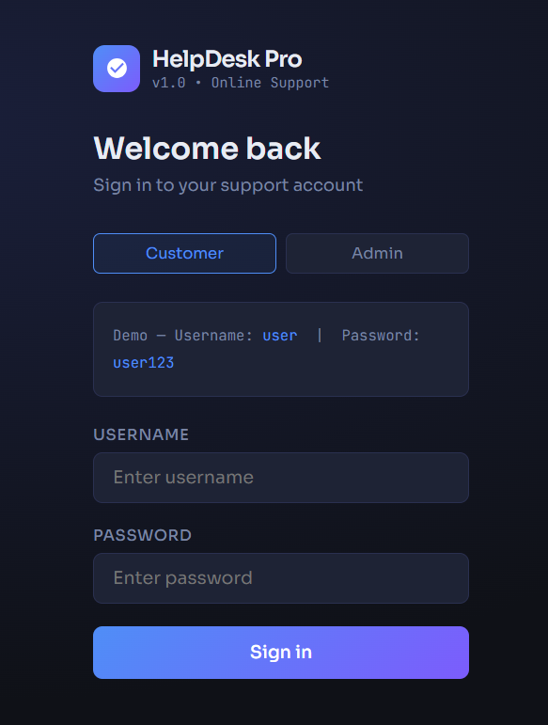

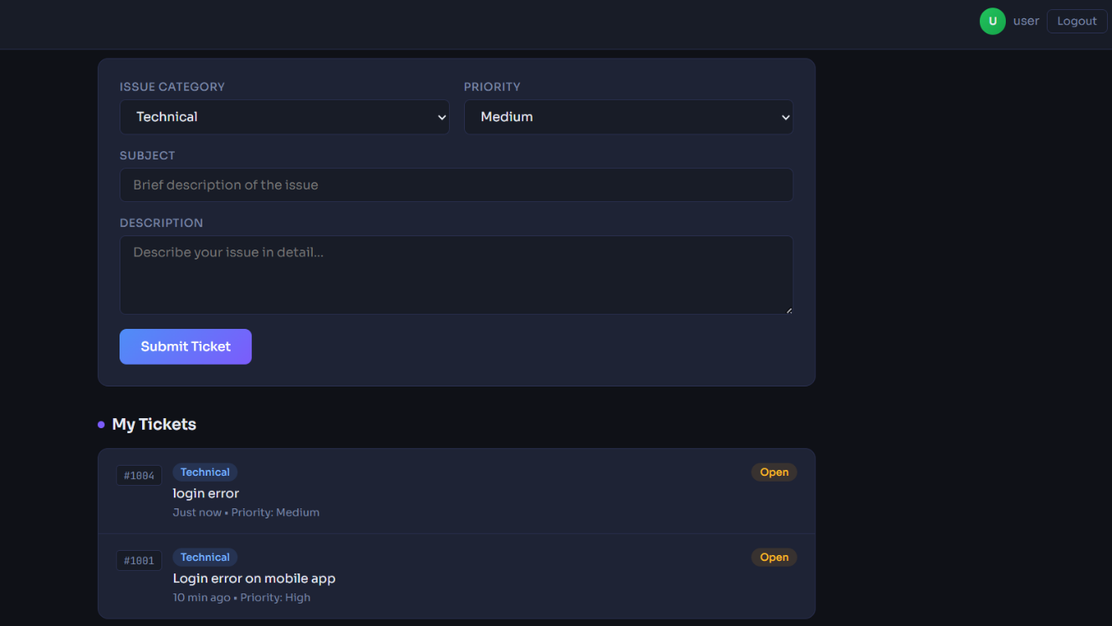

RESULT:
Thus, the Online Help Desk Support System was successfully implemented using HttpSession for session tracking, enabling login, request submission, and logout functionality.

